GDC-G4S
Test Automation Process
V1.0

Author/Editor: | Sameer Sukhija
Contributions: | Self
Distribution: | Development & Product Management
Version Control: | 1.0 | For Review

Document History

Version | Author | Date | Description
1.0 | Sameer Sukhija | 29/05/2016 | Initial version

Table of Contents

1. Objective 4
2. Test Automation process in Agile environment 4
3. Test Automation Planning 5
2.1 Scope Definition 5
2.2 Mandatory Criteria 5
2.1 Other Criteria 5
2.1 Discard Criteria 6
3 Technical Feasibility Analysis 6
4 Automation Tool Evaluation 6
5 POC (Proof Of Concept) 7
6 Automation Test Plan 7
7 Automation Framework Development 7
8 Build Test Automation Scripts 7
8.1 Automation Scripting Prerequisites 7
9 Automation Scripting 8
10 Version Control 8
11 Scripting Exit Criteria 8
12 Automation Execution 9
13 Automation Batch execution 9
14 Result Analysis 9
15 Automation documents 9
16 Test Result Report 9

Objective

This document will explain in detail different stages of automation life cycle and serve as a test automation process document. It will include various automation stages like planning, strategies, framework design and development, script development, integration with test management tool/Batch management tool, execution and creation of reports.

Test Automation process in Agile environment

The QA Specialist should ensure that the functionality developed within scrum iterations are fully automated by end of each iteration and fits within the automation framework. QA Specialist should ensure that:
- The test cases are created, reviewed and manually executed at least once.
- Reusable automated test scripts needs to be created where possible e.g. script to login to a system can be reused by many tests.

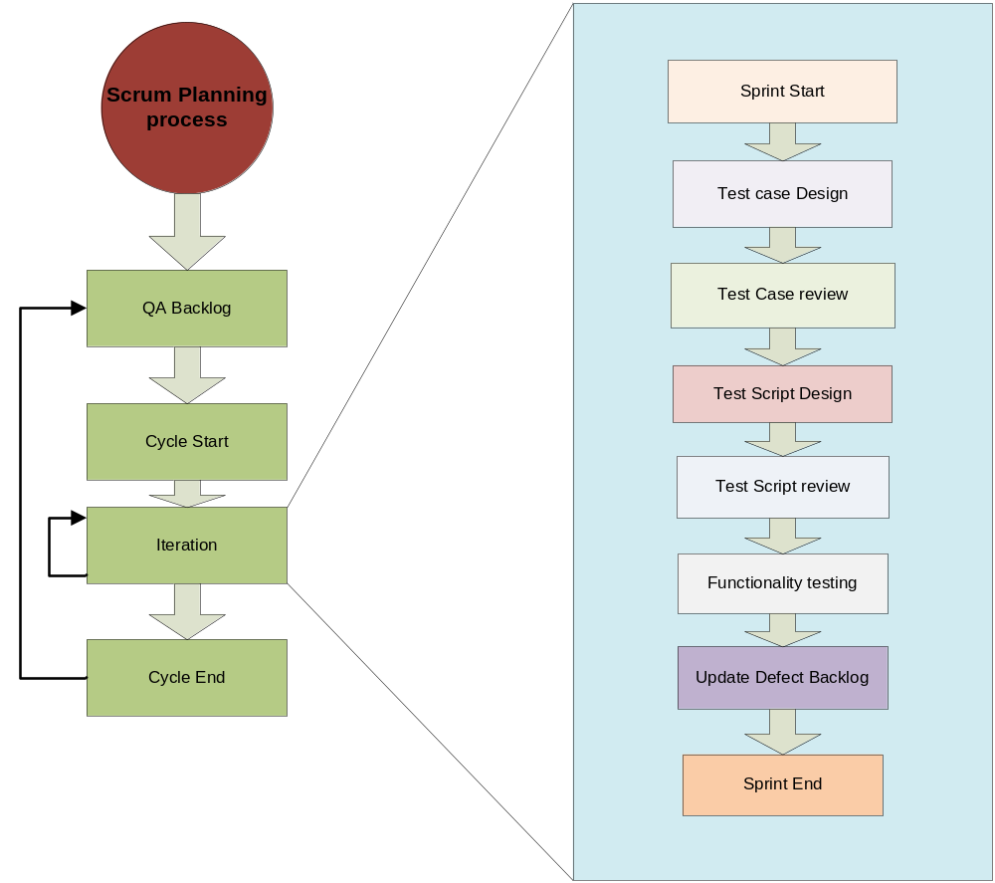

Test Automation Planning

Automation need should be identified in this phase. This will include the high level application study to identify the functional areas, which needs be automated. An appropriate QA task in JIRA should be raised with the outcome of the Automation Requirement analysis report.

Scope Definition
Once automation need is identified, scope of automation needs to be defined based on Stability, Repeatability and Criticality of the functionalities. The following Automation Entry Criteria can be used to define the scope of automation.

Mandatory Criteria

The below criteria are mandatory, without which automation will be possible but the Return Of Investment (ROI) will be less.
Sl. No. | Description
1. | The test case needs to be passed in the recent build before automating it.
2. | Frequent builds/ patches/iterations to the existing application necessitate several iterations of testing which includes this test case. (For example Smoke test/Regression tests)

Other Criteria

Once the mandatory criteria are satisfied, please go through the below criteria to gauge the test case feasibility for automation.

Sl. No. | Description
1. | Test case functionality should be complex and not very simple like Login/Logoff scripts
2. | Manual test cases which are tedious and time consuming (For e.g., generating the HIP files for all the output devices for a given publication)
3. | Test case needs to be executed for large and diverse data sets
4. | Test case needs to be executed on multiple OS combinations
5. | Test cases that need verification with a high precision
6. | Test cases are covered from different areas of application to increase automation testing coverage
7. | Test cases are reviewed and base lined for Automation

Discard Criteria

Sl. No | Discard test cases which satisfy any of the following criteria
1. | Test cases which test the Usability of the application
2. | Scenarios which reflect Random testing or Ad hoc testing
3. | Scenarios which involve testing based on Intuition
4. | Test cases which test complex Interfaces
5. | Test cases which test complex Batch programs
6. | Test case which needs Manual Intervention
7. | Test cases which requires Third Party Tool involvement needing a large amount of time to automate
8. | Test case which needs Particular Analysis
9. | One time test cases which will not be executed in future execution cycles
10. | Similar Type of test cases of same module and functionality adding no value addition to Automation

Technical Feasibility Analysis

This analysis needs to be carried out to find out from technical point of view how feasible the application is to go ahead with automation. Automation Feasibility Analysis should address the following factors,

- Technical Analysis
- Complexity
- Stability
- Availability of Test Data
- Application Size
- Repeatability

(I think we need to come up with a Questionnaire and a rating system for this).
Depending on the score of the analysis, the tester should decide the following
  - Don’t go for automation
  - Go for Proof Of Concept before automation
  - Go ahead with automation

Automation Tool Evaluation

Different automation tools need to be evaluated from technology, cost, ease of use and other parameters according to automation requirement. The possible tools to consider for the current and upcoming projects are:
- Selenium Webdriver
- SOAP UI
- POSTMAN
Also possible continuous integration tool to consider is:
- Jenkins

POC (Proof Of Concept)

If required POC needs to be carried out before starting automation. A sample scenario can be taken for automation and results can be verified to go ahead with automation or not. Evaluation copy of automation tool can be used for POC if required.

Automation Test Plan

Once decision is taken to go ahead with automation, Automation Test Plan needs to be created for the Application if the automation is aimed to replace full or some part of Functional testing. The automation plan needs to be reviewed by the following:

- The Scrum team
- Product owners
- Principal QA

Automation Framework Development

Automation framework needs to be designed and implemented. This will include defining folder structure, coding standards, different application specific libraries and implementing it, reuse existing application independent and dependent libraries.

Application Independent Libraries (DB Access, String Handling, Data Access, Exception Handling, Low Level Functions, Array Functions, Math Functions, Date & Time Functions, File Functions, and Reporting Functions) and Application Specific Libraries can be used to identify the number of functions/scripts available to reuse.

Build Test Automation Scripts

Automation Scripting Prerequisites

The following checklist criteria need to meet before start scripting.

Sr. No | Description
1. | Is the technical feasibility of automation completed?
2. | Is the financial feasibility of automation completed?
3. | Have the scope been identified for automation?
4. | Are there manual test cases reviewed and base lined for the above scope?
5. | Are the automation tools and licenses available for the automation exercise?
6. | Has the application been tested and is the functionality stable?
7. | Are the resources skilled enough to perform the automation?

Automation Scripting

Scripting will involve following activities:

- Generate Automated Scripts
- Create Data set for parameterization
- Integrate script with different libraries
- Include verification points wherever required
- Fine-tune the script for optimal performance
- Execute to debug and make it more robust
- Arrange the scripts in sequential order for ease of execution at time of regression
- Most importantly the completed script has to be code reviewed by automation lead or by a QA engineer.

Version Control

Automation artifacts need to be properly version controlled using any suitable tool. This will help to go back and get the older version of scripts/functions if required.

Scripting Exit Criteria

The following Scripting Exit Criteria can be used as a sign off checklist to consider the script ready for execution.

- Script has been reviewed for coding standards
- Review completed for indentation and comments for variables, functions, test steps etc.
- Individual Script has been executed successfully with no unexpected debug messages or message boxes
- Script and required test artefacts (Input files, Object repository, application functions etc.) have been version controlled with proper label.

Automation Execution

Once automation environment is ready for execution, all the scripts are properly integrated and test suite is ready, following activities can be performed.

Automation Batch execution

Jenkins can be used to perform the batch management of the test and this is currently being used to perform Selenium and SOAP UI tests.

Result Analysis

Once execution is over result analysis needs to be carried out to get the following details.

- Automation scripts passed
- Scripts failed due to defects
- Scripts failed due to time out
- Scripts failed due to environment issues like Application/DB/Web Server was down in between OR machine on which automation execution was going on was hanged etc.
- Failed scripts due to GUI objects were not modified or data table was not updated properly and similar type of issues related to script updates

Automation documents

Any documents related to test automation should be stored in Google Drive. A generic place for automation documents already exists in Google Drive and there are folders for each and upcoming projects also created.

- Google Drive location:

Test Result Report

Jenkins can be used to manage the results and send emails to those configured to receive the results.

